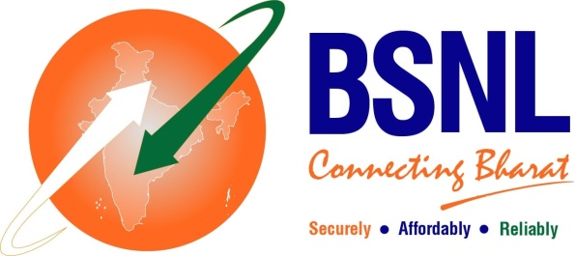

**BSNL CHENNAI TELEPHONES**

*( BSNLCO-CFAO/11(14)/3/2020-CFA-Part(2) dtd 03/10/2024)*

**FESTIVAL OFFER**

BSNL is happy to introduce **Festival offer** for **New FTTH** connections booked under FTTH plans **Fibre Basic Neo** and **Fibre Basic**. In this offer, the customer can avail:

1. Rent free FTTH during the first calendar month.
2. A discounted FMC of Rs. 399 for the next three months, after the free service period.
3. This offer is also available for customers migrating from Copper to FTTH.
4. This offer is available from 1st Oct 2024 to 31st Dec 2024.

Hurry Book your FTTH connection now!!

<https://bookmyfiber.bsnl.co.in/> or connect with us (dial or whatsapp) on 1800 4444